Using Machine Learning to Predict Collision SeverityStudying Collision Data from 2004 to 2020 for the Seattle Dept. of Transportation  
Sam Steffes | August 26, 2020

## Introduction

In the Spring of 2015, the Seattle Department of Transportation (SDOT) released a 10-year Strategic Vision for providing safe and sustainable transportation infrastructure for the city. This plan highlighted the adoption of a *Vision Zero* goal to eliminate serious and fatal crashes by the year 2030. However, as demonstrated in the figure below, while the annual volume of total collisions has decreased 27.6% since 2015, the number of severe collisions (those where injuries or fatalities occur) has decreased by only 18.4%, and has accounted for a larger portion of all incidents year-over-year since the report was released. This suggests that the initiatives and actions implemented to reduce collisions, while successful, are not adequately targeting the conditions or locations that result in severe collisions.

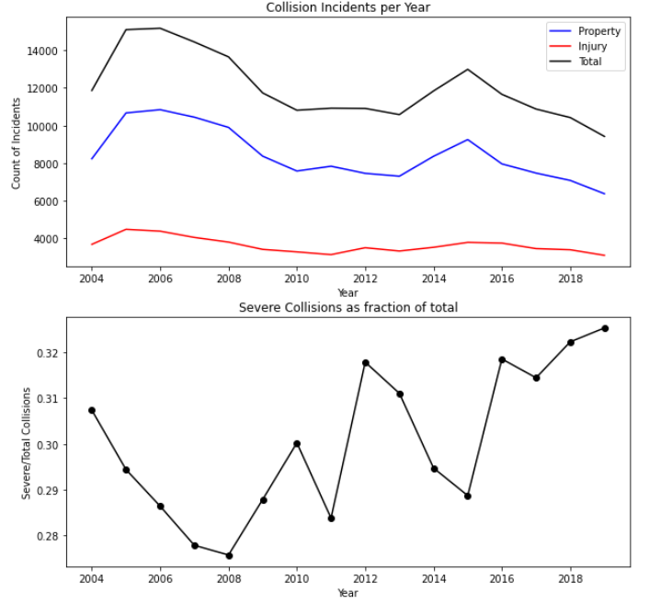  
*Figure 1 – Trend in collision results from 2004-2019.*

Developing programs and strategies that accelerate the elimination of severe collisions first requires a better understanding of why they occur. Since the severity of collisions likely depends on many conditions, obvious correlation with discrete parameters would be difficult to identify. Therefore, a machine learning model that can evaluate a diverse feature-set and predict outcomes is a more effective analytical approach. A model that accurately predicts the severity of collisions offers several benefits for the SDOT’s efforts to improve roadway safety, such as:

* identifying the factors that most contribute to severe collisions, allowing more targeted improvements,
* providing a way to quantify (evaluate) and select improvement options that have the most benefit (i.e. reduction in severe incidents), and
* supporting the development and deployment of decision-support tools that optimize emergency response services and dispatch them more effectively.